**Kubernates**

**Container Registry :**

1. **Name : Kubermageshwaricr**
2. **Username : kubermageshwaricr**
3. **Password : 456H0FXG+yMm+93lpy3YNOS00hjrkh+FpUBwPgsJN/+ACRBCuXKs**
4. 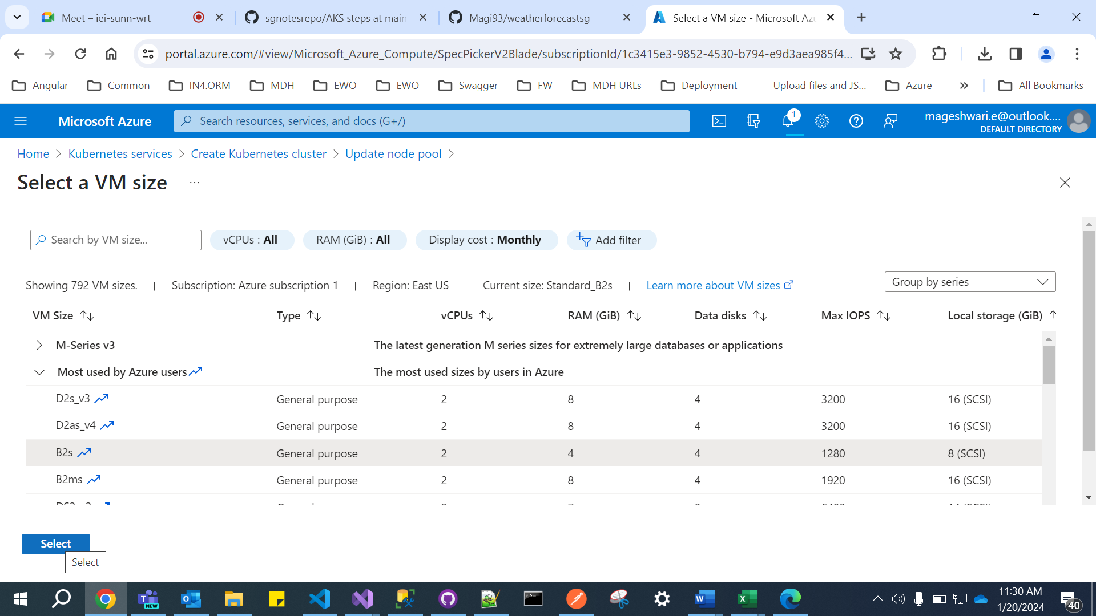
5. 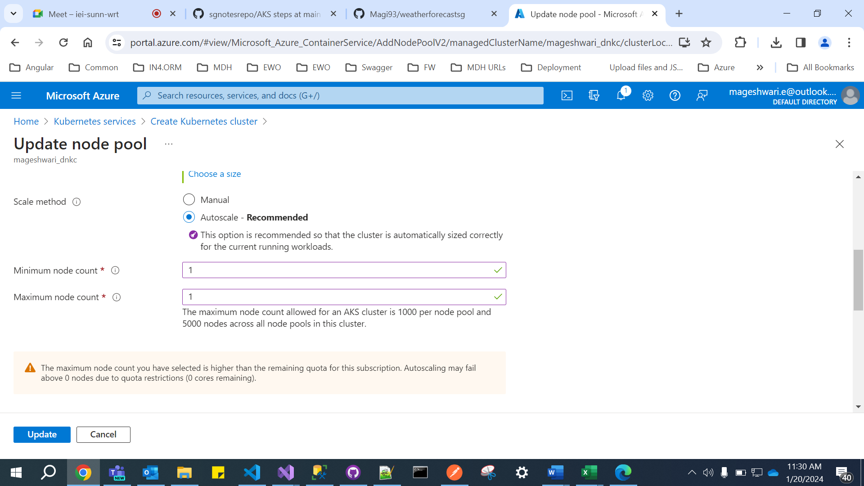

## az aks get-credentials --resource-group SGGroup --name mageshwari_dnkc

## kubectl create secret docker-registry dsconfigsn1 --docker-server=kubermageshwaricr.azurecr.io --docker-username=kubermageshwaricr --docker-password=456H0FXG+yMm+93lpy3YNOS00hjrkh+FpUBwPgsJN/+ACRBCuXKs [--docker-email=Mageshwari.e@outlook.com](mailto:--docker-email=Mageshwari.e@outlook.com)

## 

## 

## 

## 

## 

## 

## 

## 

## 

## 

## 

